**1. SECTION – 1 : Azure Application Insights** 1

**2. SECTION – 2 : ELK** 8

# **1. SECTION – 1 : Azure Application Insights**

1. We use the same solution i.e **Cart and Payment Service -Saga Pattern**.
2. Select the Resource group in Azure Portal.

1. Install the below Serilog NuGet Package in WebApp Project.

1. Define the Serilog configuration in appsettings.json file and appsettings.development.json file. Comment default logging from both the file.

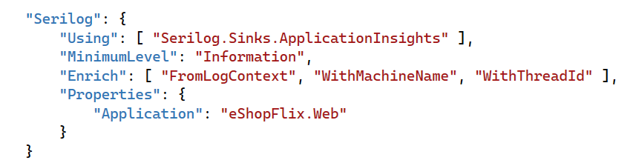

1. In Program.cs file of WebApp project, define the Application Insights settings.

1. Add a Helper class inside Helpers folder of WebApp for Logging the errors.
2. WebApp project > HomeController Index action method, we raise the divide by zero exception intentionally.
3. Create a section AppInsightConnection under WebApp appsettings.json file and add the below Azure Insight connection string in that section.

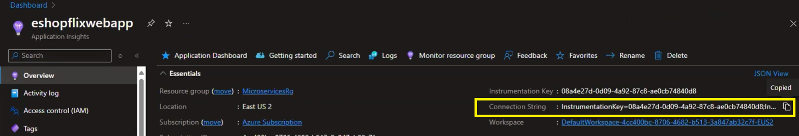

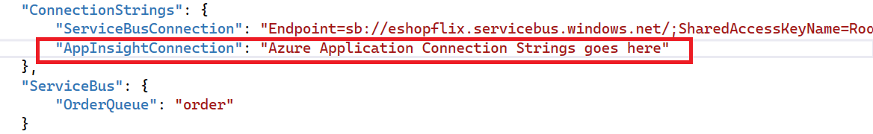

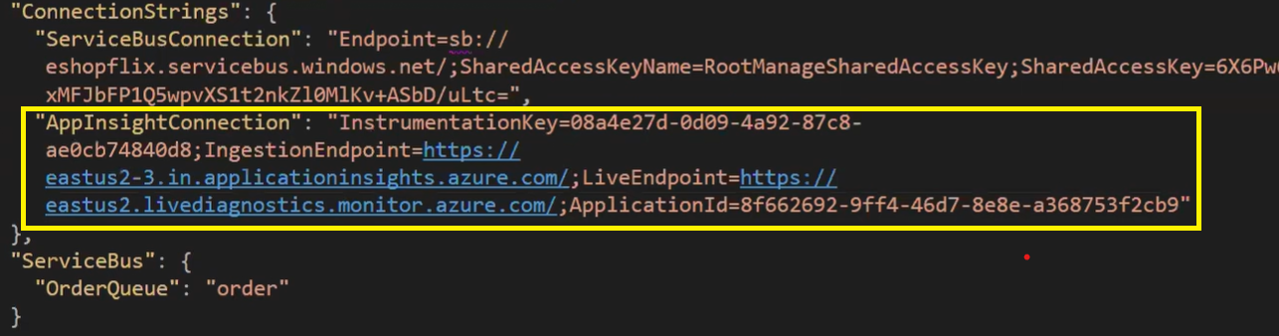

Run the application. Exception is getting

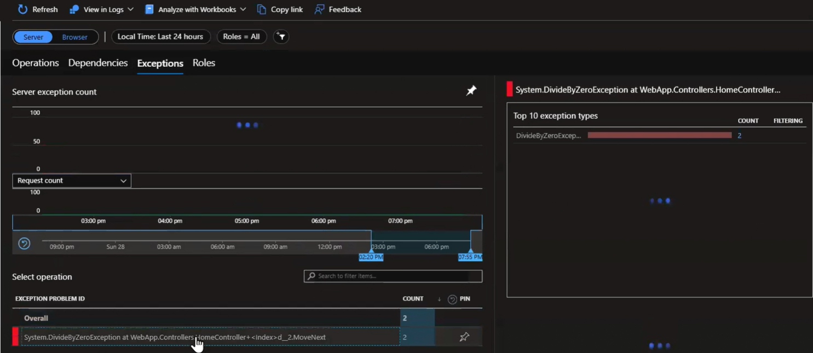

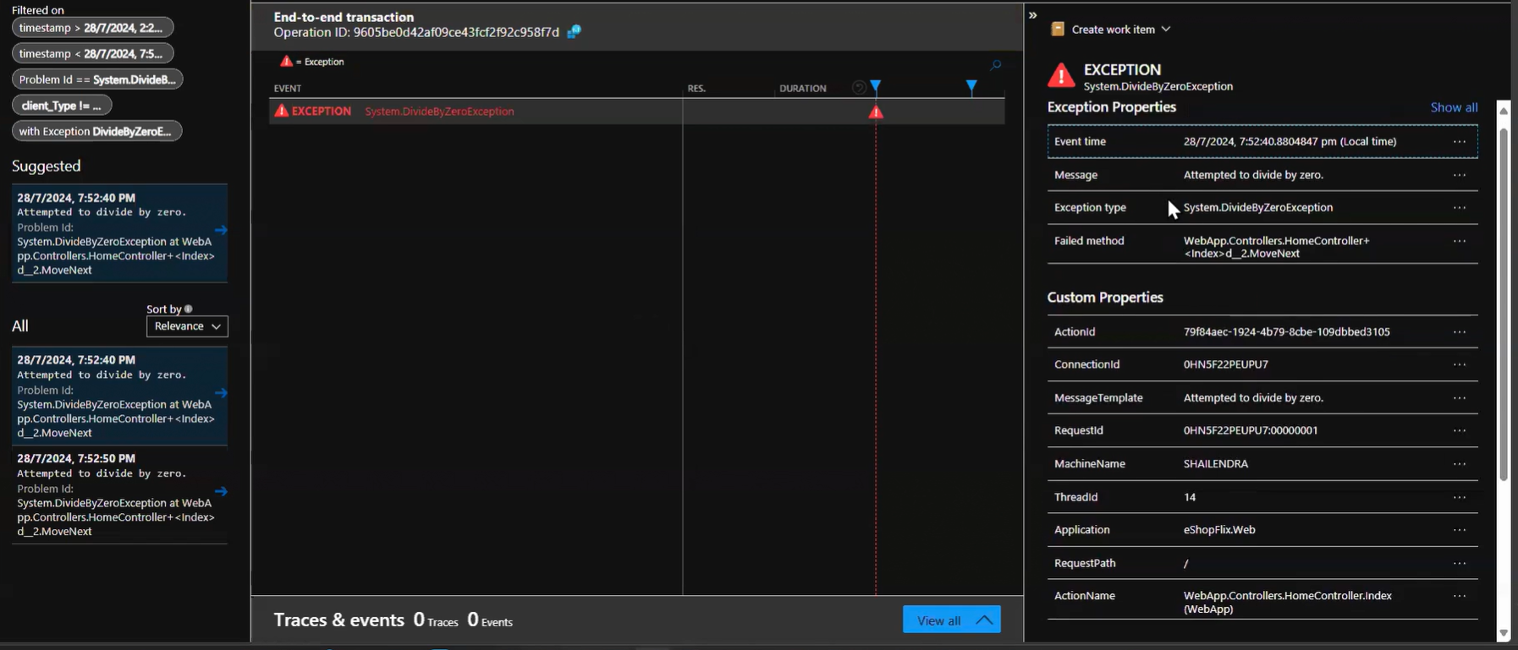

# **2. SECTION – 2 : ELK**

1. ELK Setup. Follow the below steps.

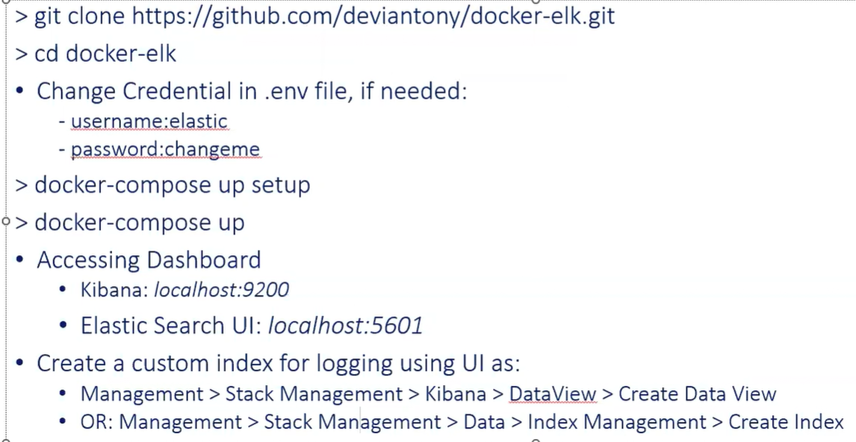

1. Clone the repository.

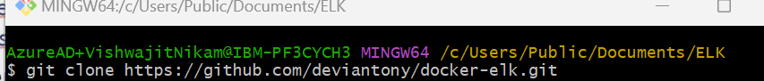

1. Open the Code in Visual Studio Code.

Open Docker Desktop. Execute the below docker command in VS Code terminal.



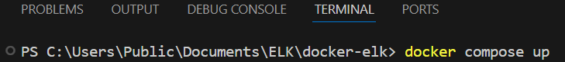

1. Run <http://localhost:9200/> in chrome.
2. Run <http://localhost:5601> in another chrome tab.
3. If take some time then, disabled the K8s from docker desktop.
4. On port 5601, it ask the below credentials

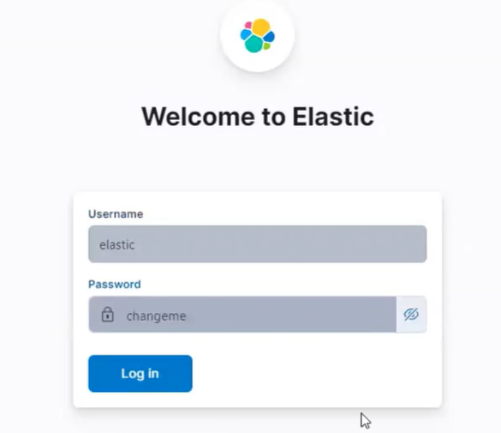

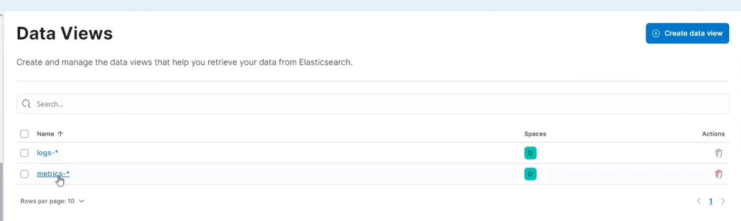

1. Create a ASP.NET Core Web API project. Named it as LogService. Add the below Serilog NuGet Packages.

1. Add Model Folder inside LogService project.
2. CatalogService > ProductController > Add action method, intentionally raise the divide by zero execution and add the code in exception block.
3. Add the HttpClient in Program.cs file of CatalogService.
4. Inject the HttpClientFactory in ProductController of CatalogService project.
5. Add the LogService Address url in CatalogService of appsettings.json file.
6. Add Model Folder inside CatalogService project.
7. Replace the default logging configuration with Serilog in appsettings.json file of LogService project.
8. Add the Serilog configuration in Program.cs file of LogService project.

1. Add the wwwroot > Logs folder inside the LogService
2. Start CatalogService and LogService as a start up project.

